AI ASSISTED CODING LAB 7.2

TOPIC: Error Debugging with AI: Systematic approaches to finding and fixing bugs

ENROLLMENT NO: 2403A52006

NAME: MOHAMMED MUSTAFA

COURSE: CSM(AI/ML)

BATCH: 01

DATE: 16-09-2025

Task 1: Syntax Error in Conditionals

Used Prompt:

a = 10

if a = 10:

print("equal")  
In the given code, mention the error and give the corrected code

Corrected Code:

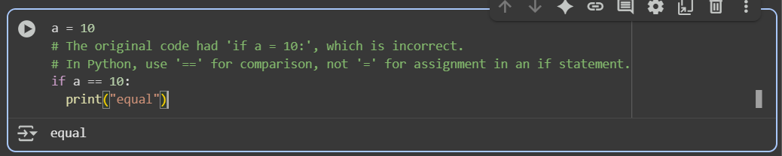

Error Explanation:  
The error in the code we should use double == not only single = to check equality of a number.

Task 2: Loop Off-By-One Error.

Used prompt:

def sum_upto_n(n):

total = 0

for i in range(1,n):

total +=i

return total

In the given code identify and mention the error like the previous cell and correct the code

Corrected Code:

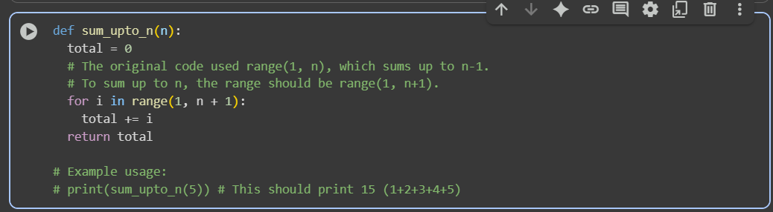

Error Explanation:

The error is in the given range(1, n).To calculate the sum, the range used should be range (1, n+1).

TASK 3: Attribute Error

Used Prompt:

class user: def _init_(self,name):

self.name = name

u = user("Alice")

print(u.getname())

In the given code identify the error, mention it and correct the code

Corrected Code:

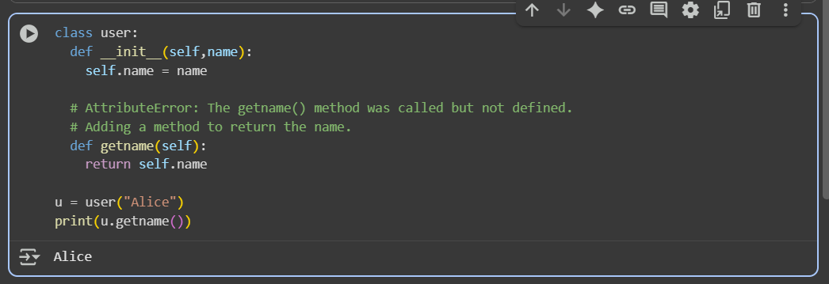

Error Explanation:

The getname() method is called, but not defined in the user class.

TASK 4: Incorrect Class Attribute Initialization

Used Prompt:

class Car:

def start():

print("Car Started")

mycar = Car()

mycar.start()

in the given code identify the error in the code mention it and give the corrected code

Corrected Code:

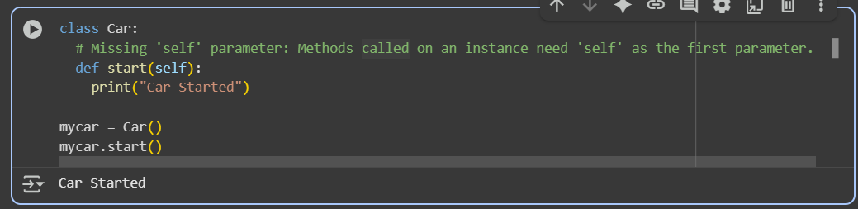

Error Explanation:

When defining a method in a class that will be called on an instance of the class (like mycar), the first parameter of the method should be self, which refers to the instance itself.

TASK 5: Conditional Logic Error in Grading System

Used Prompt:

def grade_student(score):

if score < 40:

return "A"

elif score < 70:

return "B"

else: return "C"

in this code, make changes that if score >:= 90 return A if score < 70 return B else return C

Corrected Code:

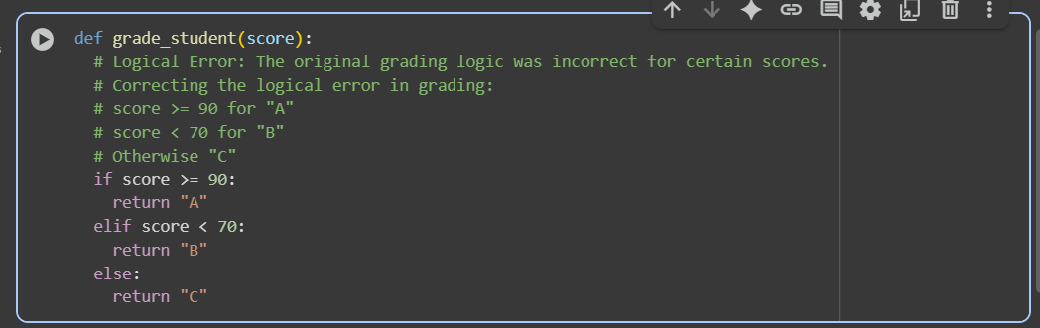

Error Explanation:

In this code we have a logical error. The corrected logic is that if score >=90 return A, if score > 70 return B and if score < 40 return C